NAME:N.Sravanthi
Batch 23
Experiment 6: AI-Based Code Completion: Working with suggestions for classes,loops,conditionals
Task Description #1 (AI-Based Code Completion for Loops)
Task: Use an AI code completion tool to generate a loop-based
program.
Expected Output:
• AI-generated loop logic.
• Identification of loop type used (for or while).
• Validation with sample inputs.
Prompt:
Generate Python code to print all even numbers between 1 and N using a loop. Identify the loop type and validate it with two sample inputs and outputs.
CODE:
N = int(input("Enter a number N: "))
print(f"Even numbers between 1 and {N}:")
for num in range(1, N + 1):
if num % 2 == 0:
print(num)
OUTPUT:
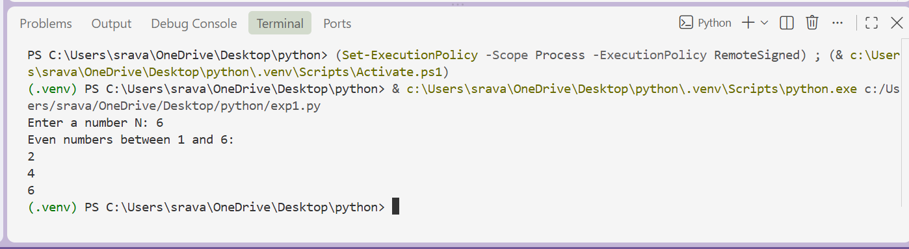
Task Description #2 (AI-Based Code Completion for Loop with
Conditionals)
Task: Use an AI code completion tool to combine loops and
condion
Expected Output:
• AI-generated code using loop and if condition.
• Correct count validation.
• Explanation of logic flow.
PROMPT:
Generate Python code to count the even and odd numbers in a list using a loop and if condition. Show the code, explain the logic, and validate the counts with a sample input.
CODE:
numbers = [12, 5, 8, 9, 21, 14, 7, 18]
even_count = 0
odd_count = 0
for num in numbers:
if num % 2 == 0:
even_count += 1
else:
odd_count += 1
print("List:", numbers)
print("Even numbers:", even_count)
print("Odd numbers:", odd_count)
# Logic:
# - The for loop checks each number in the list.
# - If the number is divisible by 2, it is even, so even_count increases.
# - Otherwise, it is odd, so odd_count increases.
# - Final values are printed after the loop ends.
# Validation with sample input:
# Even numbers = 4 (12, 8, 14, 18)
# Odd numbers = 4 (5, 9, 21, 7)
OUTPUT:
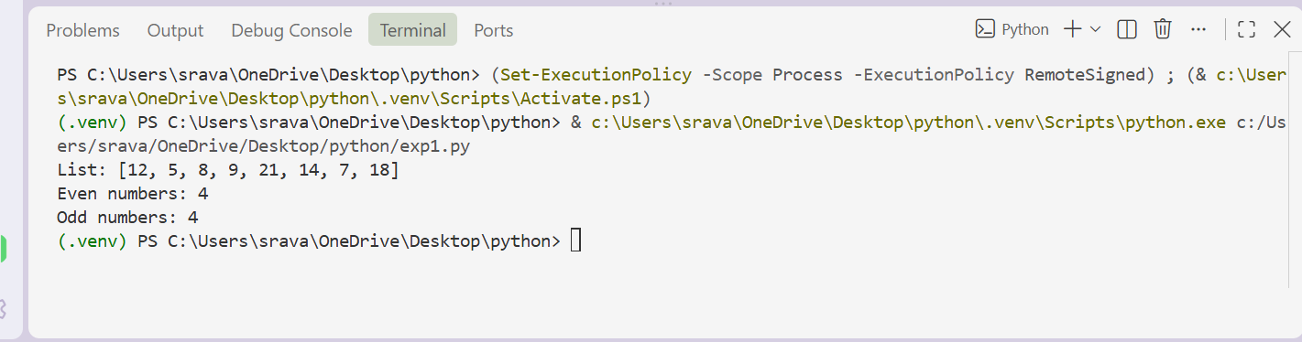
Task Description #3 (AI-Based Code Completion for Class
Attributes Validation)
Task: Use an AI tool to complete a Python class that validates user
input.
Expected Output:
• AI-generated class with validation logic.
• Verification of condition handling.
• Test cases for valid and invalid inputs.
PROMPT:
Generate a Python class User that validates age and email using if conditions. Show the validation logic and test cases for valid and invalid inputs.
CODE:
class User:
def __init__(self, name, age, email):
self.name = name
self.age = age
self.email = email
if age < 0:
raise ValueError("Age cannot be negative.")
if age < 18:
raise ValueError("User must be at least 18 years old.")
if "@" not in email or "." not in email:
raise ValueError("Email must contain '@' and '.'.")
def __str__(self):
return f"User(name={self.name}, age={self.age}, email={self.email})"
# Test cases
# Valid input
user1 = User("Alice", 25, "alice@example.com")
print(user1)
# Invalid age
try:
User("Bob", 17, "bob@example.com")
except ValueError as e:
print("Invalid age:", e)
# Invalid email
try:
User("Charlie", 30, "charlieexample.com")
except ValueError as e:
print("Invalid email:", e)
# Negative age
try:
User("Dana", -5, "dana@example.com")
except ValueError as e:
print("Invalid negative age:", e)
OUTPUT: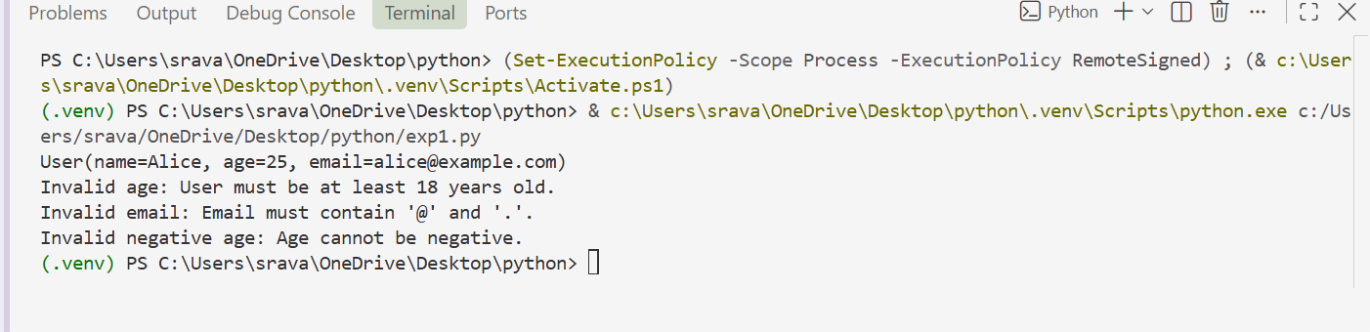
Task Description #4 (AI-Based Code Completion for Classes)
Task: Use an AI code completion tool to generate a Python class for
managing student details.
Expected Output:
• AI-generated class code.
• Verification of correctness and completeness of class
structure.
• Minor manual improvements (if needed) with justification.
PROMPT:
Generate a Python class Student with name, roll number, and marks attributes, plus methods to calculate total and average marks. Verify the class structure and suggest minor improvements with justification.
CODE:
class Student:
"""Represents a student with a name, roll number, and marks."""

def __init__(self, name, roll_number, marks=None):
self.name = name
self.roll_number = roll_number
self.marks = marks if marks is not None else []

def total_marks(self):
"""Return the sum of all marks."""
return sum(self.marks)
def average_marks(self):
"""Return the average of the marks. Returns 0.0 if there are no marks."""
if not self.marks:
return 0.0
return self.total_marks() / len(self.marks)

if __name__ == "__main__":
# Verification of the class structure and behavior.
student = Student("Alice", 101, [80, 90, 85])

assert student.name == "Alice"
assert student.roll_number == 101
assert student.marks == [80, 90, 85]
assert student.total_marks() == 255
assert student.average_marks() == 85.0
empty_student = Student("Bob", 102)
assert empty_student.total_marks() == 0
assert empty_student.average_marks() == 0.0
# Minor improvements with justification:
# 1. Add type hints like name: str, roll_number: int, marks: list[int] | None.
# This makes the API clearer and helps tools catch errors early.
# 2. Validate marks to ensure they are numeric and within a valid range.
# This prevents invalid data from producing incorrect totals or averages.
# 3. Consider using a method name like add_marks() for extending the list.
# It improves readability and keeps the class easier to expand.
OUTPUT:
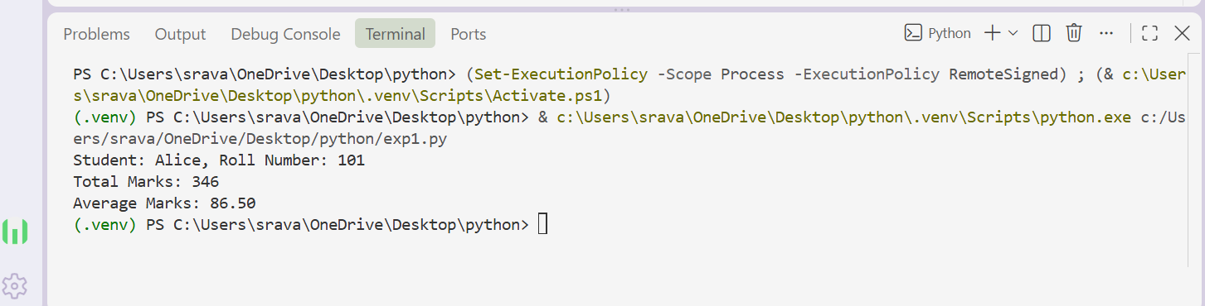
Task Description 5 (AI-Assisted Code Completion Review)
Task: Use an AI tool to generate a complete Python program using
classes, loops, and conditionals together.
Expected Output:
• Complete AI-generated program.
• Identification of strengths and limitations of AI suggestions.
• Reflection on how AI assisted coding productivity.
PROMPT:
Generate a complete Python bank account system using a class, loops, and conditional statements. Explain the program, identify its strengths and limitations, and reflect on how AI improved coding productivity.
CODE:
class BankAccount:
"""Represents a bank account with basic transaction features."""

def __init__(self, account_number, owner_name, balance=0.0):
self.account_number = account_number
self.owner_name = owner_name
self.balance = balance

def deposit(self, amount):
"""Deposit money into the account."""
if amount <= 0:
return "Deposit amount must be greater than zero."
self.balance += amount
return f"Deposited ${amount:.2f}. New balance: ${self.balance:.2f}"

def withdraw(self, amount):
"""Withdraw money from the account if funds are available."""
if amount <= 0:
return "Withdrawal amount must be greater than zero."
if amount > self.balance:
return "Insufficient funds. Withdrawal failed."
self.balance -= amount
return f"Withdrew ${amount:.2f}. Remaining balance: ${self.balance:.2f}"

def check_balance(self):
"""Return the current balance."""
return f"Account {self.account_number} balance: ${self.balance:.2f}"

def display_details(self):
"""Show the account details."""
return (
f"Account Number: {self.account_number}\n"
f"Owner: {self.owner_name}\n"
f"Balance: ${self.balance:.2f}"
)

def create_account(accounts):
"""Create a new bank account."""
while True:
account_number = input("Enter account number: ").strip()
if account_number in accounts:
print("Account number already exists. Try again.")
else:
break

owner_name = input("Enter account holder name: ").strip()
while True:
try:
balance = float(input("Enter opening balance: "))
if balance < 0:
print("Balance cannot be negative.")
else:
break
except ValueError:
print("Please enter a valid numeric balance.")

accounts[account_number] = BankAccount(account_number, owner_name, balance)
print(f"Account created successfully for {owner_name}.")

def find_account(accounts):
"""Find an account by its account number."""
account_number = input("Enter account number: ").strip()
if account_number in accounts:
return accounts[account_number]
print("Account not found.")
return None

def main():
"""Run the banking system menu."""
accounts = {}

print("Welcome to the Bank Account System")
print("================================")

while True:
print("\nMenu:")
print("1. Create Account")
print("2. Deposit")
print("3. Withdraw")
print("4. Check Balance")
print("5. View Account Details")
print("6. List All Accounts")
print("7. Exit")

choice = input("Choose an option (1-7): ").strip()

if choice == "1":
create_account(accounts)

elif choice == "2":
account = find_account(accounts)
if account is not None:
while True:
try:
amount = float(input("Enter deposit amount: "))
break
except ValueError:
print("Please enter a valid number.")
print(account.deposit(amount))

elif choice == "3":
account = find_account(accounts)
if account is not None:
while True:
try:
amount = float(input("Enter withdrawal amount: "))
break
except ValueError:
print("Please enter a valid number.")
print(account.withdraw(amount))

elif choice == "4":
account = find_account(accounts)
if account is not None:
print(account.check_balance())

elif choice == "5":
account = find_account(accounts)
if account is not None:
print(account.display_details())

elif choice == "6":
if not accounts:
print("No accounts available.")
else:
print("\nAll accounts:")
for account in accounts.values():
print(account.display_details())
print("-" * 30)

elif choice == "7":
print("Thank you for using the bank account system. Goodbye!")
break

else:
print("Invalid option. Please choose a number from 1 to 7.")

if __name__ == "__main__":
main()
